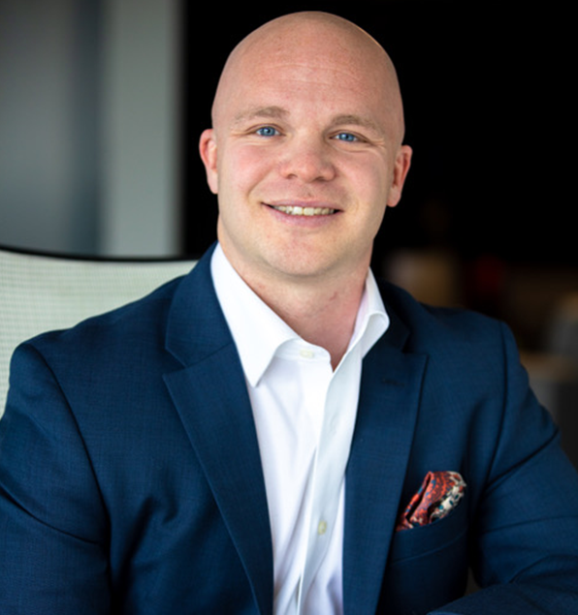

Phillip Clark, founder of ENABLE Special Needs Planning, helps families across the country plan for abundant futures for their loved ones. His younger sister, Sarah, has Down syndrome and is the catalyst for his unique approach to planning.

He believes that planning should enable our loved ones to live happy, fulfilling, and purposeful lives—today and in the future.

Early in his career, he realized the industry’s approach to special needs planning only prepared parents for when they were no longer able to care for their children.

While having a plan for life’s future “What Ifs” is vital, as a proud big brother, he knew families needed better conversations about planning centered around creating opportunities for success today.

Phil is a Chartered Special Needs Consultant (ChSNC®). He enjoys volunteering with the special needs ministry at Mercy Road Church, Down Syndrome Indiana, and Gigi’s Playhouse Indianapolis, and recently served as a founding board member for Same As U, a lifelong learning day program for adults with intellectual and developmental disabilities.

