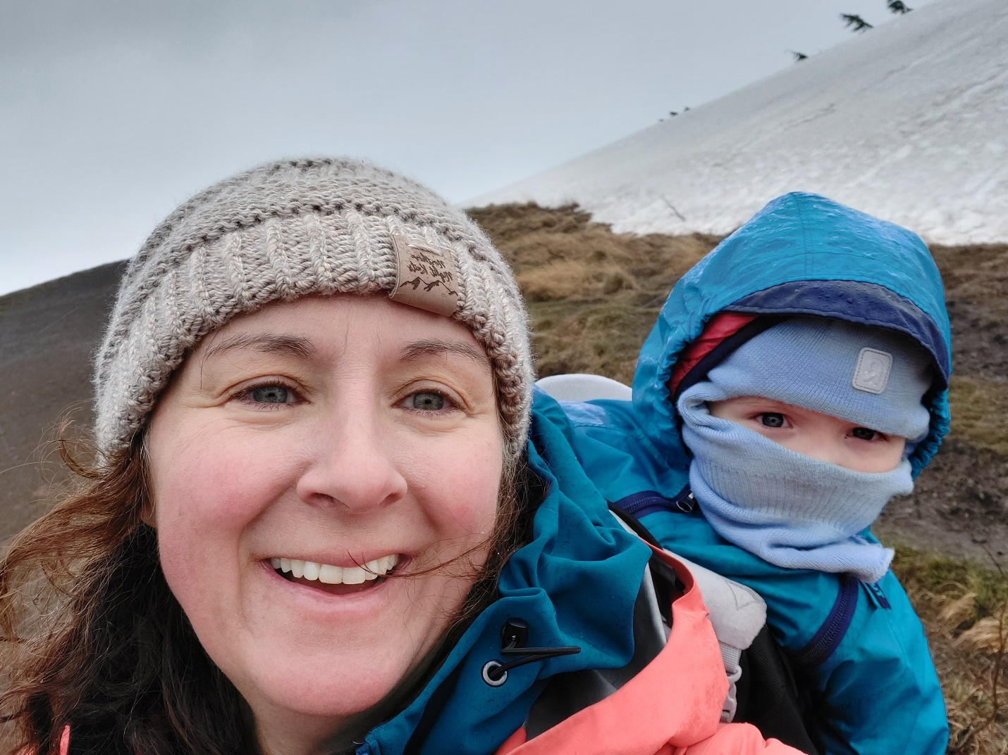

Joanne is originally from Scotland and came to the United States over 25 years ago. She received her Master’s in Social Work from the University of Nebraska at Omaha and began a 13 year career as a medical social worker at Fairbanks Memorial in 2002. In 2004 she moved to Chicago and in 2010 began working at Lurie Children’s Hospital in downtown Chicago, as a pediatric transplant social worker. While there she became very interested in adolescent healthcare transition and prevention work. After earning a Master’s in Public Health from the University of New England in 2017, Joanne moved back to Alaska and began working as a Public Health Specialist in 2018, for the State of Alaska in the Section of Women’s, Children’s, and Family Health. Her current roles include Program Manager for the State of Alaska Metabolic Clinic and Children and Youth with Special Health Care Needs (CYSHCN) and working with the Alaska Newborn Bloodspot Screening Program. At the beginning of the COVID-19 pandemic in March 2020, Joanne embraced the opportunity to offer medical services through telehealth and continues to work collaboratively to improve systems of care and access to medical services for CYSHCN. In her free time Joanne loves exploring Alaska, hiking, running, rafting, skiing, and camping with family, friends, and her aussie mix puppy Munro.

